HTML -Hyper text markup language (Skeleton)

CSS – Cascading Style Sheets (Styling)

JAVA SCRIPT – (Functioning)

<https://code.visualstudio.com/download> Installation

Live server Installation

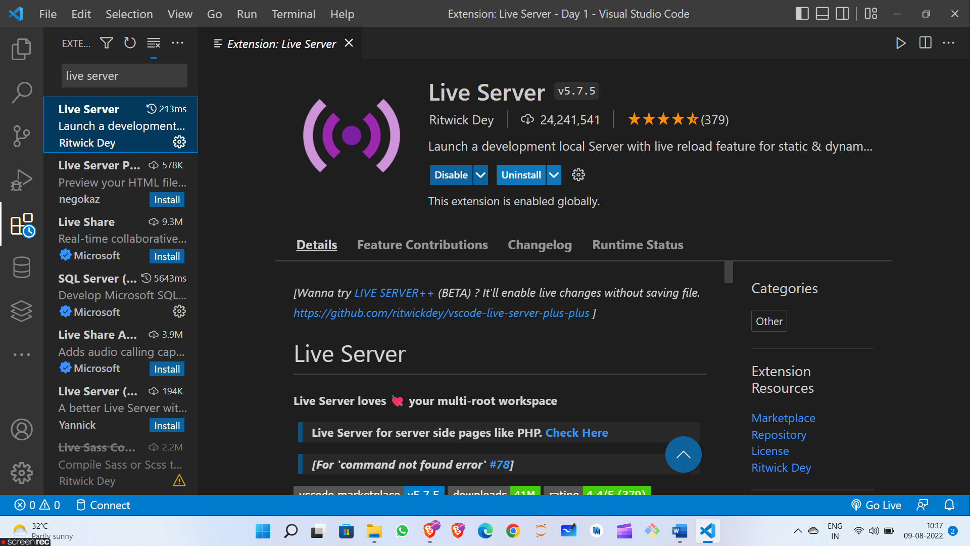

Html

Tags <>

Opening Tags closing tags

<> </>

Self Closed

<>

Heading tags – h1 h2 h3 ….. – used for describing headings

Paragraph tags – p – used for describing large texts

For getting text bold we use -- <strong> </strong> or <b> </b>

For getting italic font we use --- <em> </em> or <i> </i>

<br> for Breaking the line b/w paragraphs

<hr> for horizontal line